**Online Movie Review System – Version 1.0**

**Have Done:**

Login, if enter wrong info, will jump to error page.

Register, must enter username and password. If missing one of them, will return error page. If enter existed name, will return error page.

List all movie titles, and you can click title to get detail info of this movie.

List all actor name, and you can click name to get detail info of this actor.

Search by keyword, by clicking different button to do different search. Search by actor, you will get actor name list, also you can click name to get detail info of this actor. Search by movie, you will get movie title list, also you can click name to get detail info of this movie.

List all movie title from review table.

List all movie title from comments_on table

Logout to login page.

**Screenshots:**

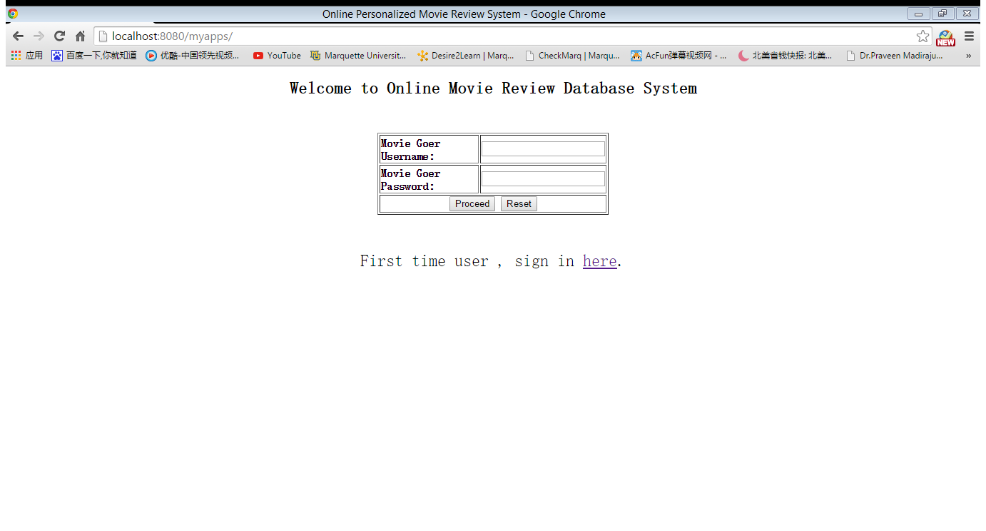

Login page

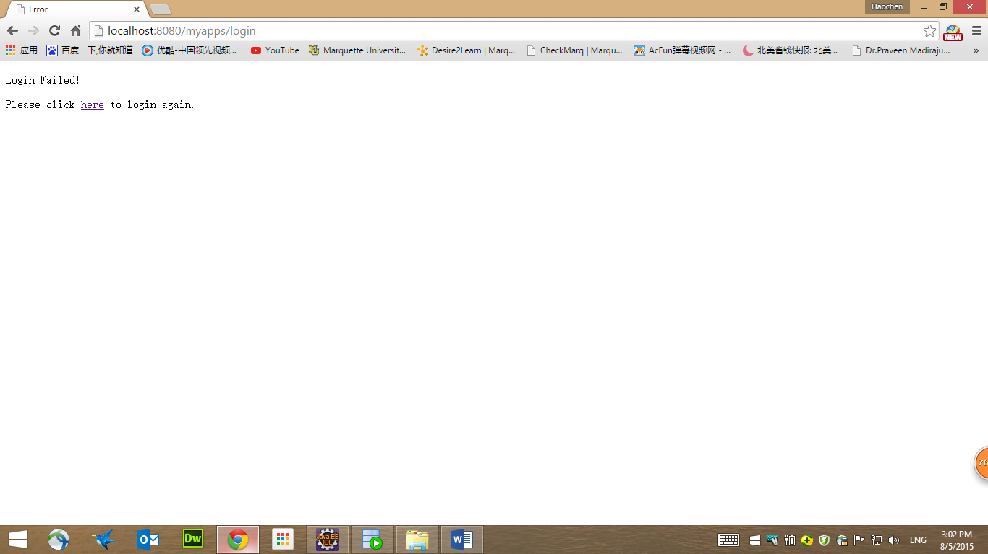

Error page

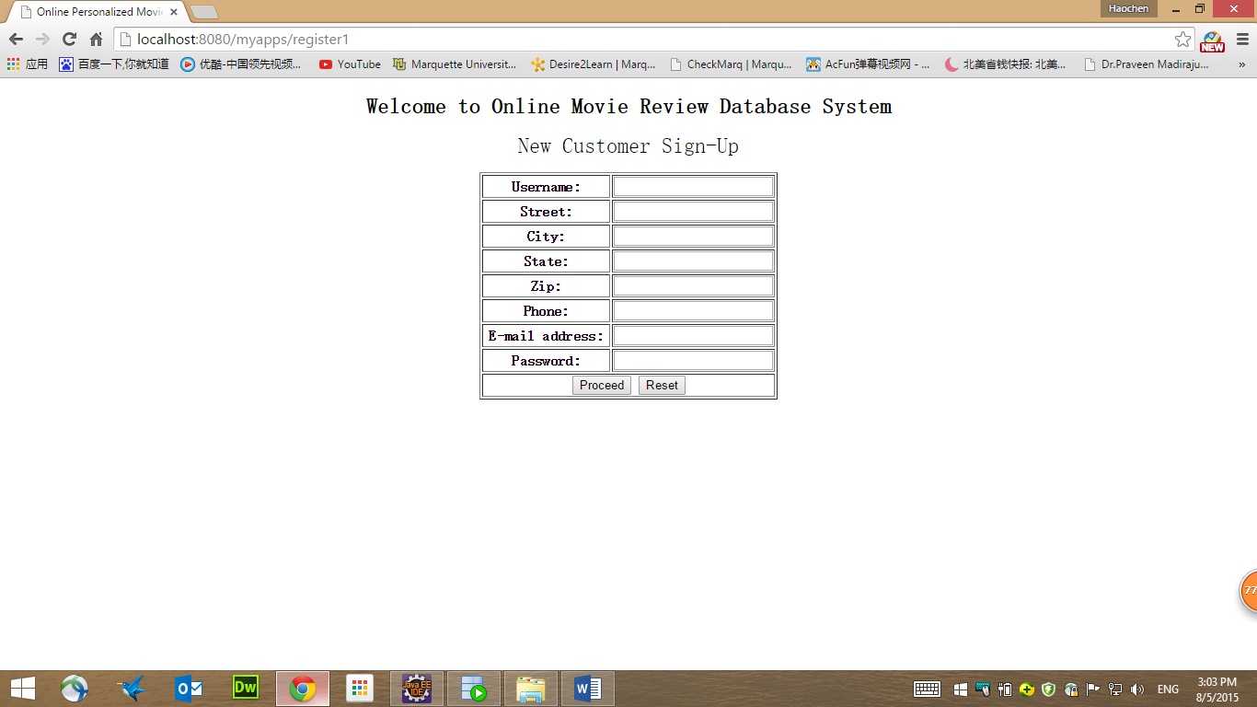  
Register page

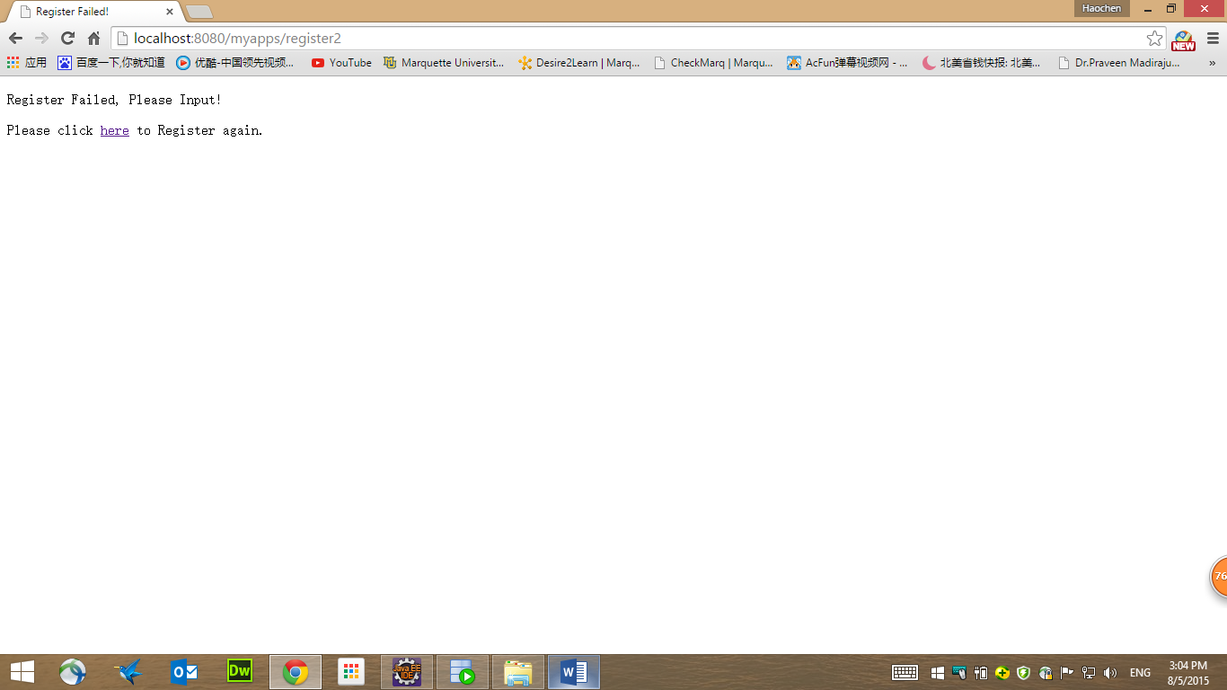

Error page

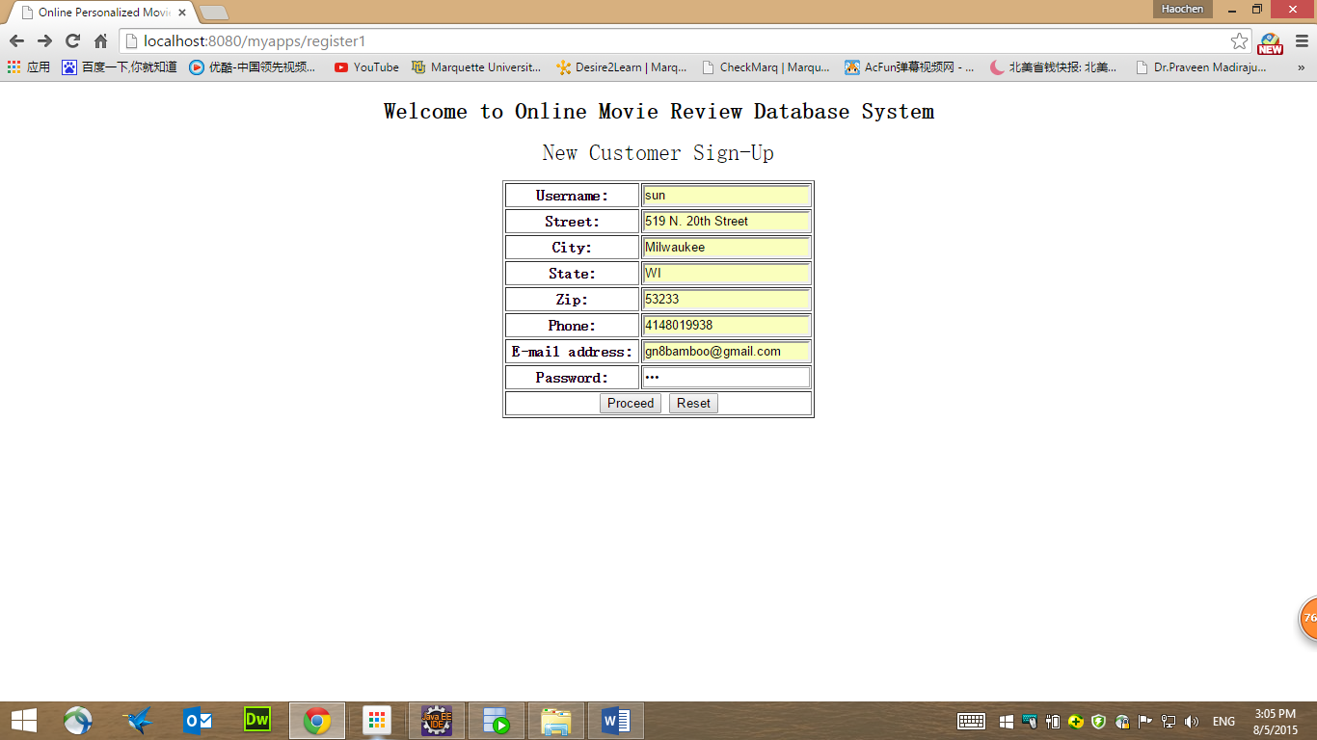

Register successful, return menu page.

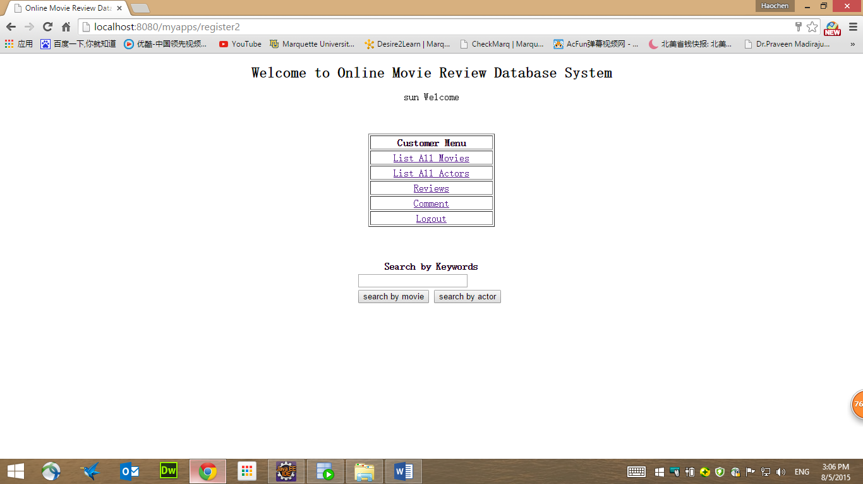

Menu page

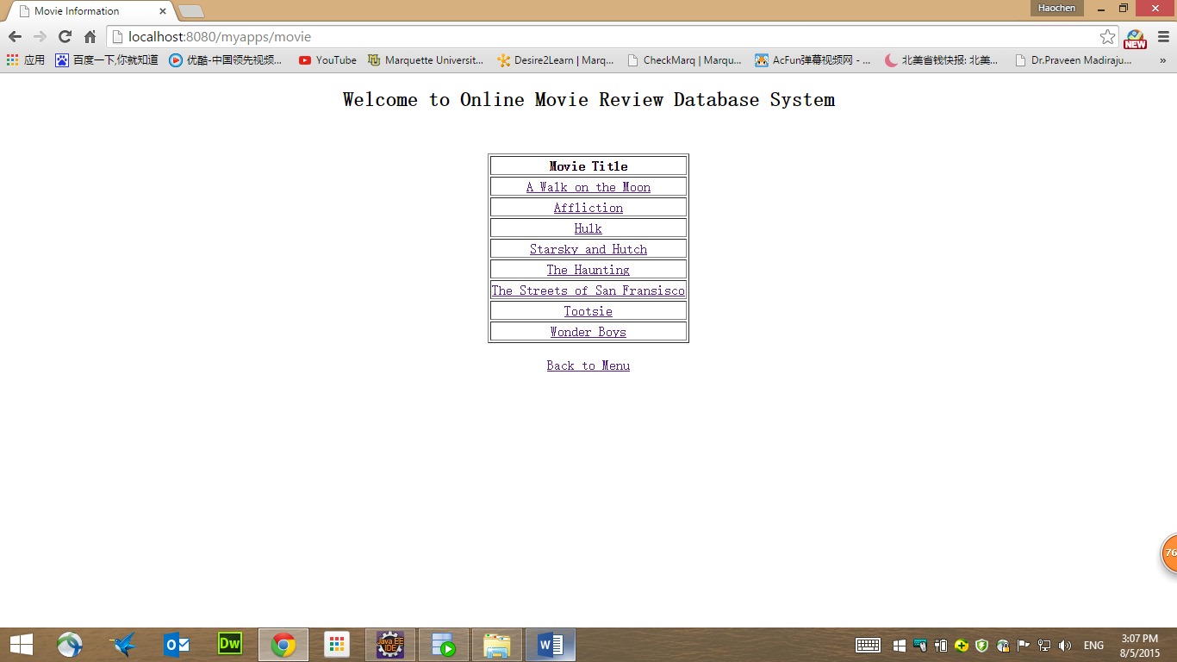  
List movie title page

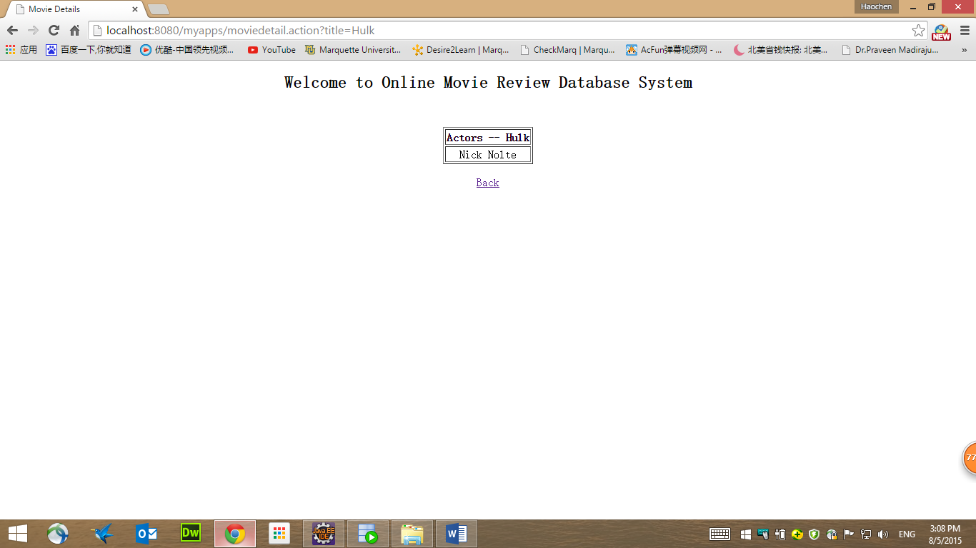

Movie detail page

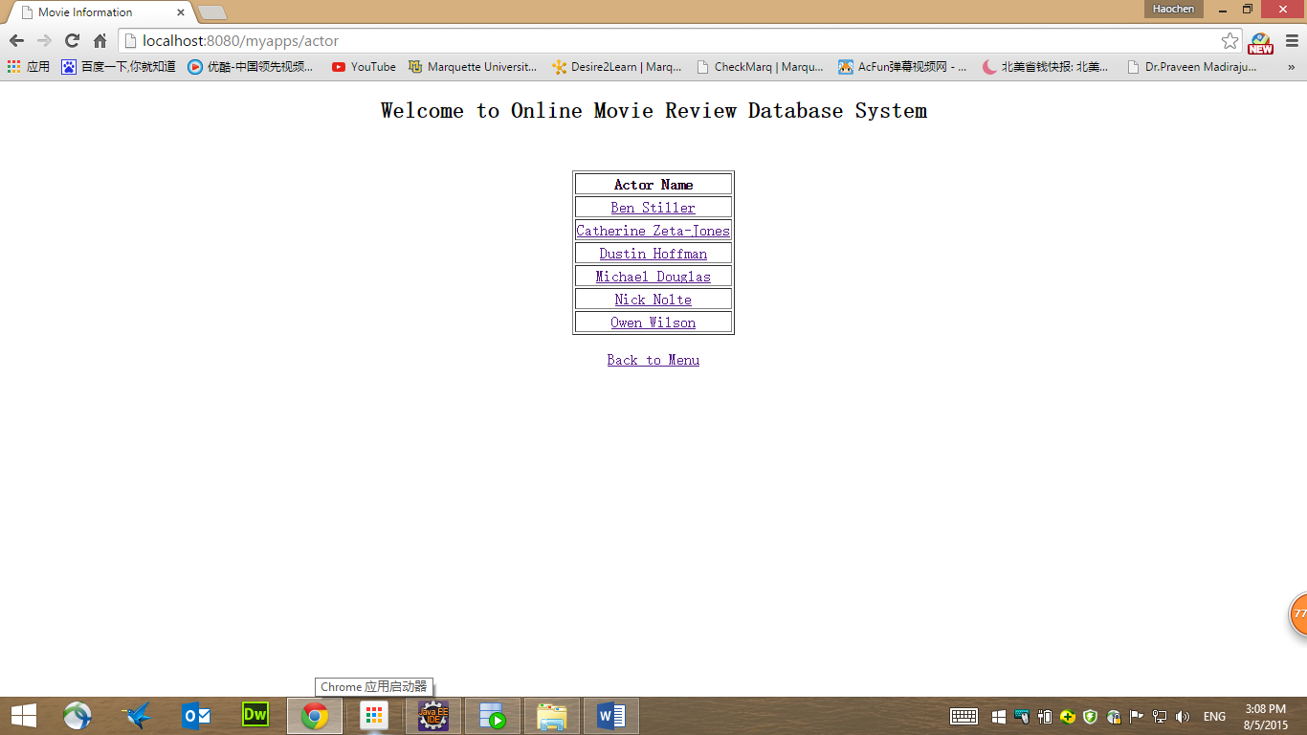

List all actor name page

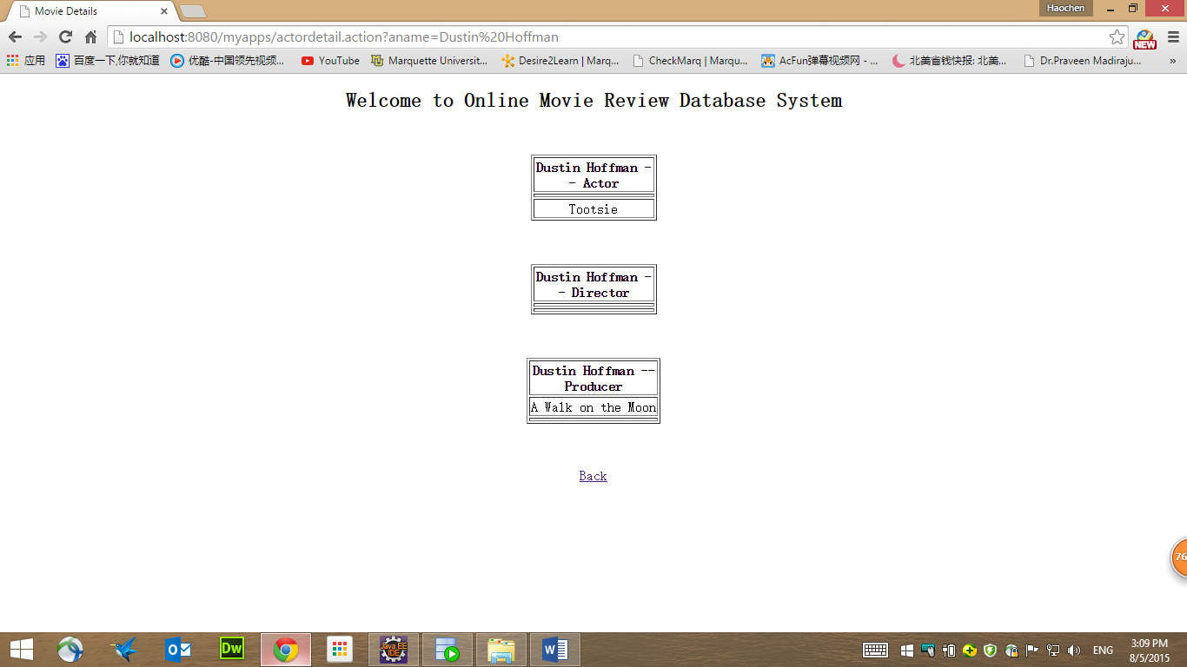

Actor detail page

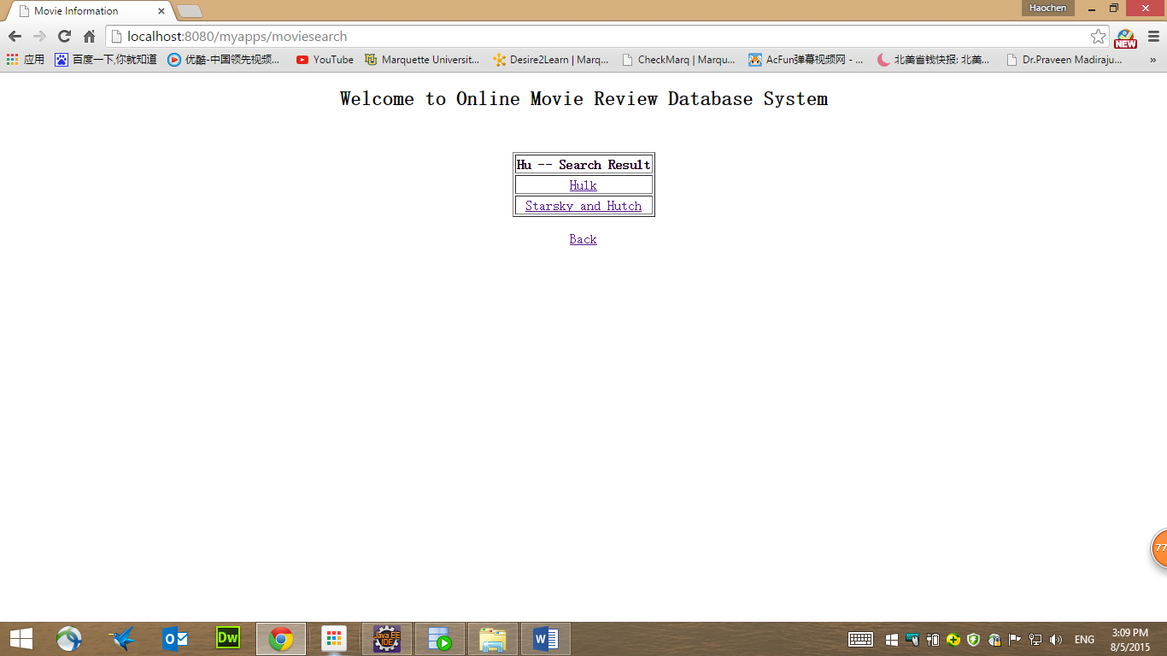

Search by movie title

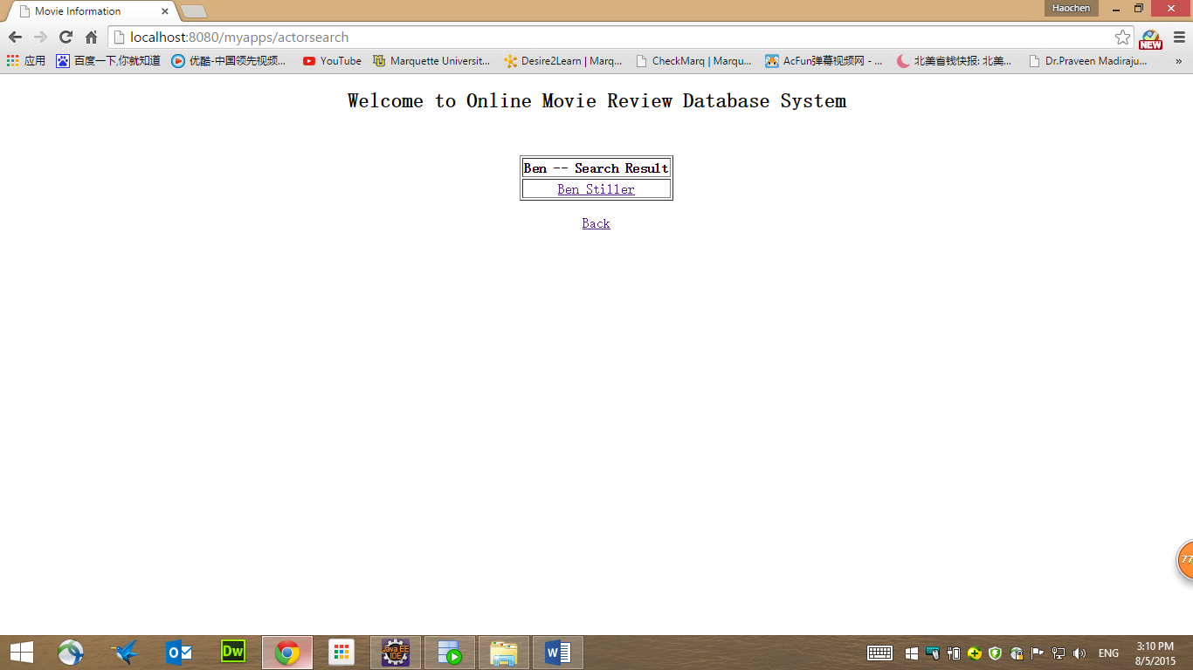

Search by actor name

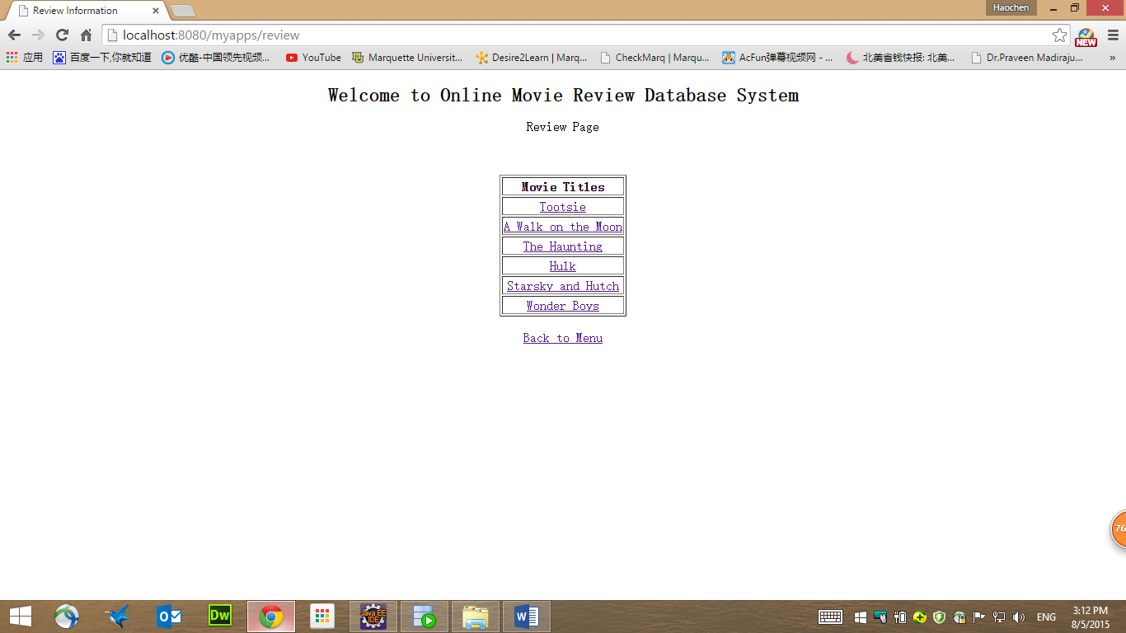

Review page

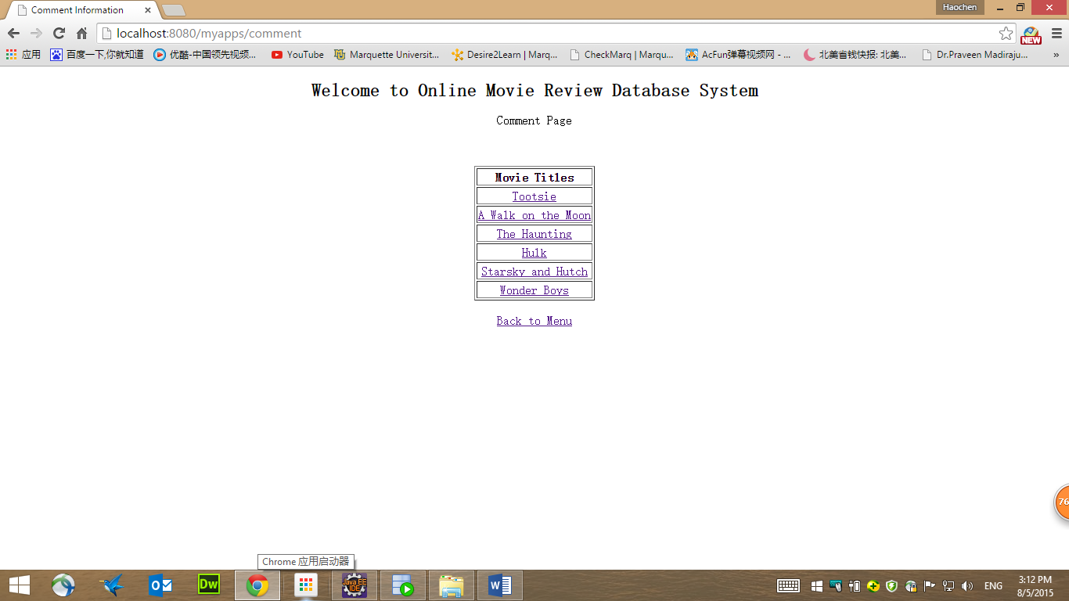

Comment page